|  |  |
| --- | --- |
|  | LAB 10: Analysis of Ethernet frames and various network topologies.. |
|  |  |
|  | Akshar Panchani ID- 202101522  IT304 Computer Networks  11/22/23 |



**Exercise:**

**1.2:**

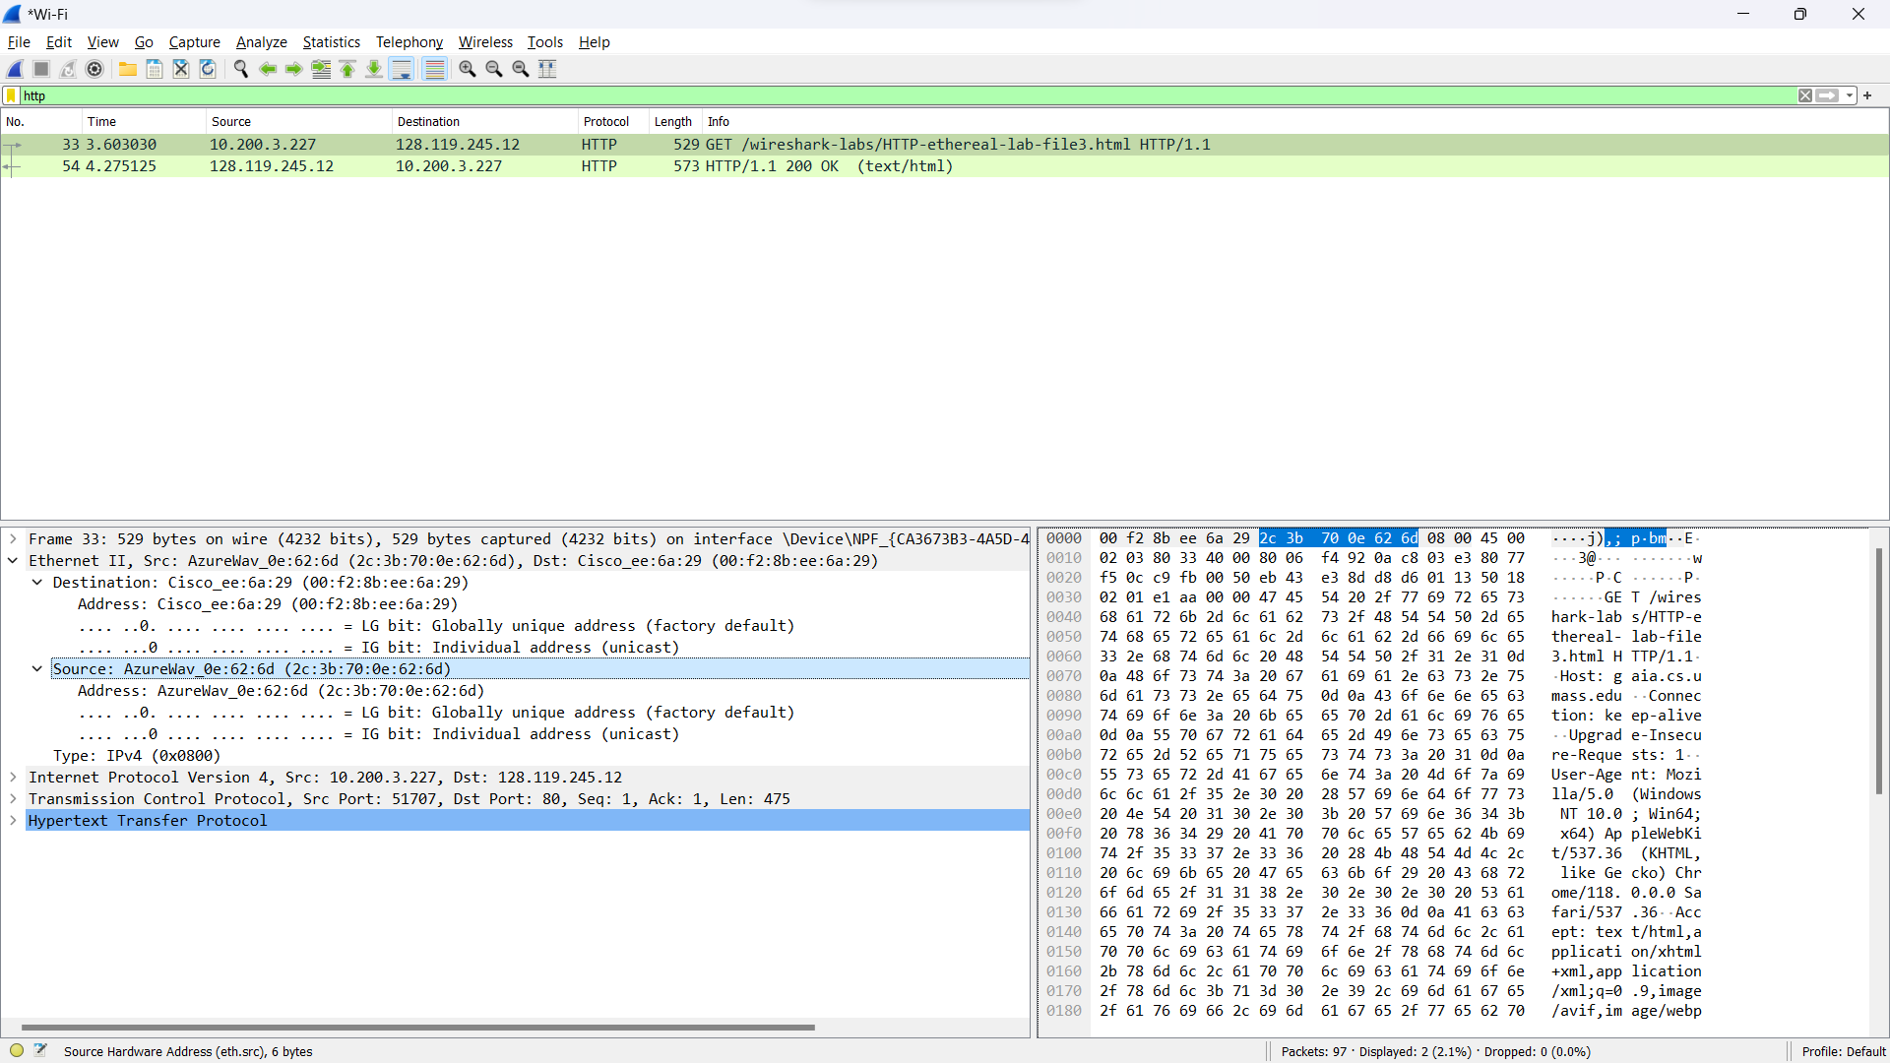

1. What is the 48-bit Ethernet address of your computer?

* The ethernet address of my computer is 2c-3b-70-0e-62-6d.

1. What is the 48-bit destination address in the Ethernet frame? Is this the Ethernet address of gaia.cs.umass.edu? What device has this as its Ethernet address?

* The destination address = 00-f2-8b-ee-6a-29.
* It is not the ethernet address of the website but the ethernet address of the next hop router.

1. Give the hexadecimal value for the two-byte Frame type field. What do the bit(s) whose value is 1 mean within the flag field?

* The value for the two-byte frame type is 0x0800 and the LG bit is set to 0 which means that it is globally unique address.

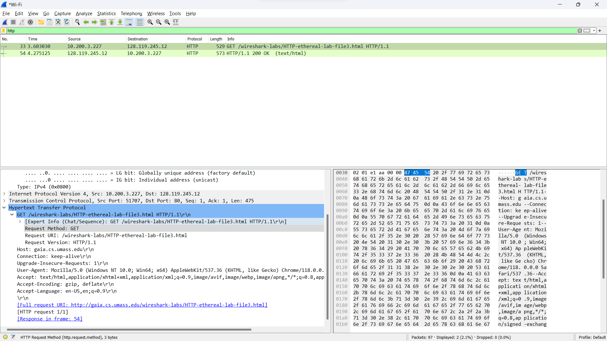

How many bytes from the very start of the Ethernet frame does the ASCII “G” in “GET” appear in the Ethernet frame?

* The ASCII ‘G’ in ‘GET’ appears 54 bytes from the start of the frame. It is shown that the ‘G’ starts from 47 bytes and we have 54 bytes before it.

1. What is the hexadecimal value of the CRC field in this Ethernet frame?

* There is no CRC field in the ethernet frame.

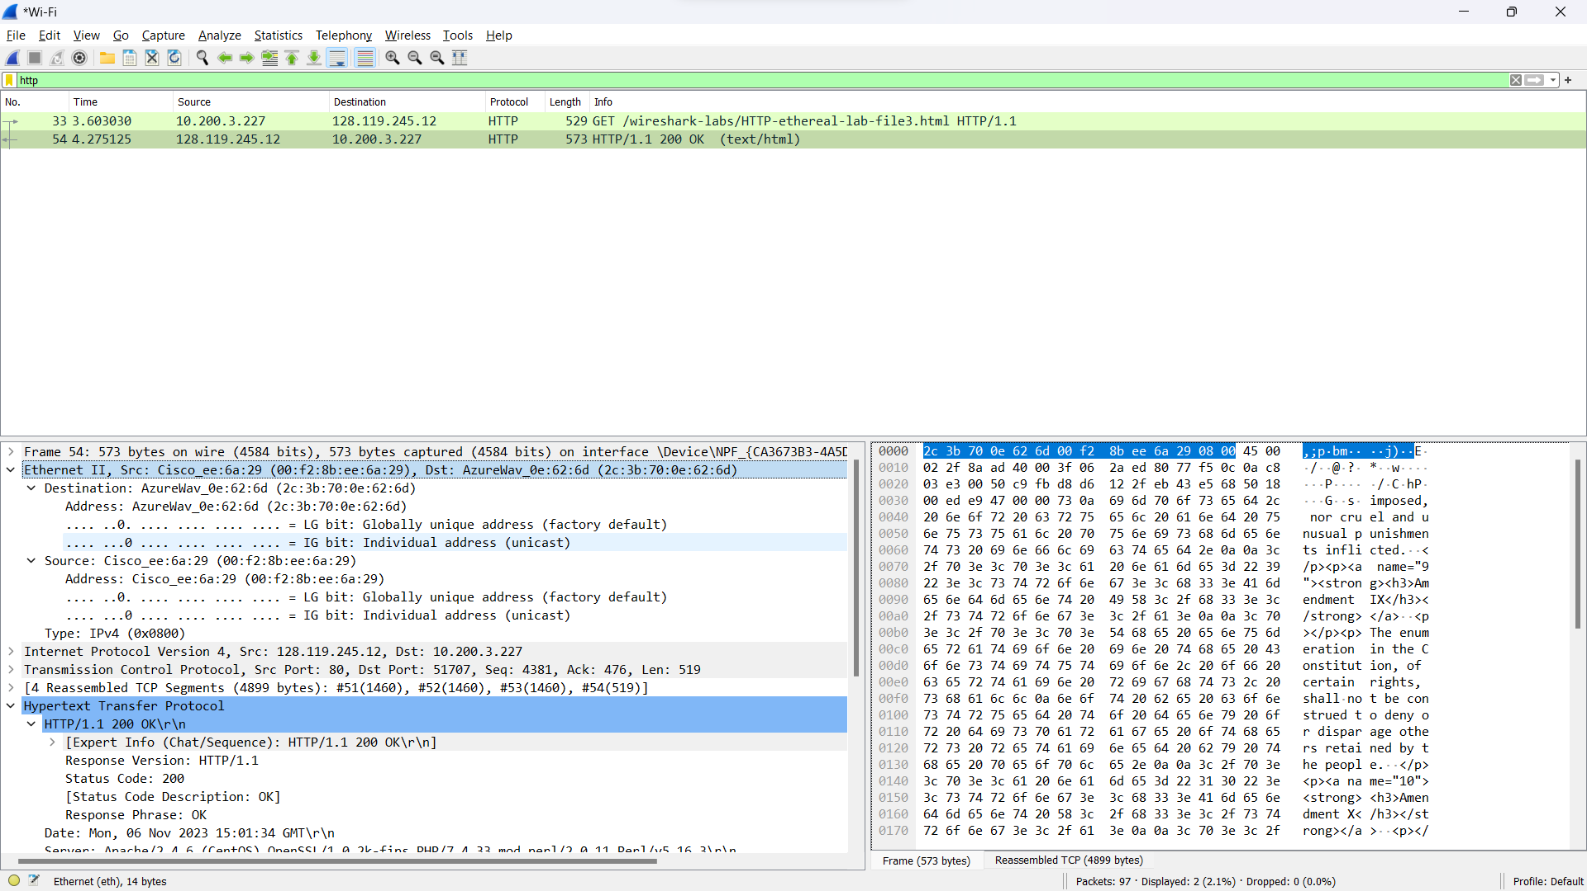

1. What is the value of the Ethernet source address? Is this the address of your computer, or of gaia.cs.umass.edu. What device has this as its Ethernet address?

* The ethernet source address is 00-f2-8b-ee-6a-29.
* It is not the address of the gaia.cs.umass.edu but it is the address of the next hop router for my device.

1. What is the destination address in the Ethernet frame? Is this the Ethernet address of your computer?

* The destination address is 2c-3b-70-0e-62-6d which is the address of my device.

1. Give the hexadecimal value for the two-byte Frame type field. What do the bit(s) whose value is 1 mean within the flag field?

* The value for the two-byte type field is 0x0800 and the LG bit of the destination address is set to 0 which means that it globally unique address.

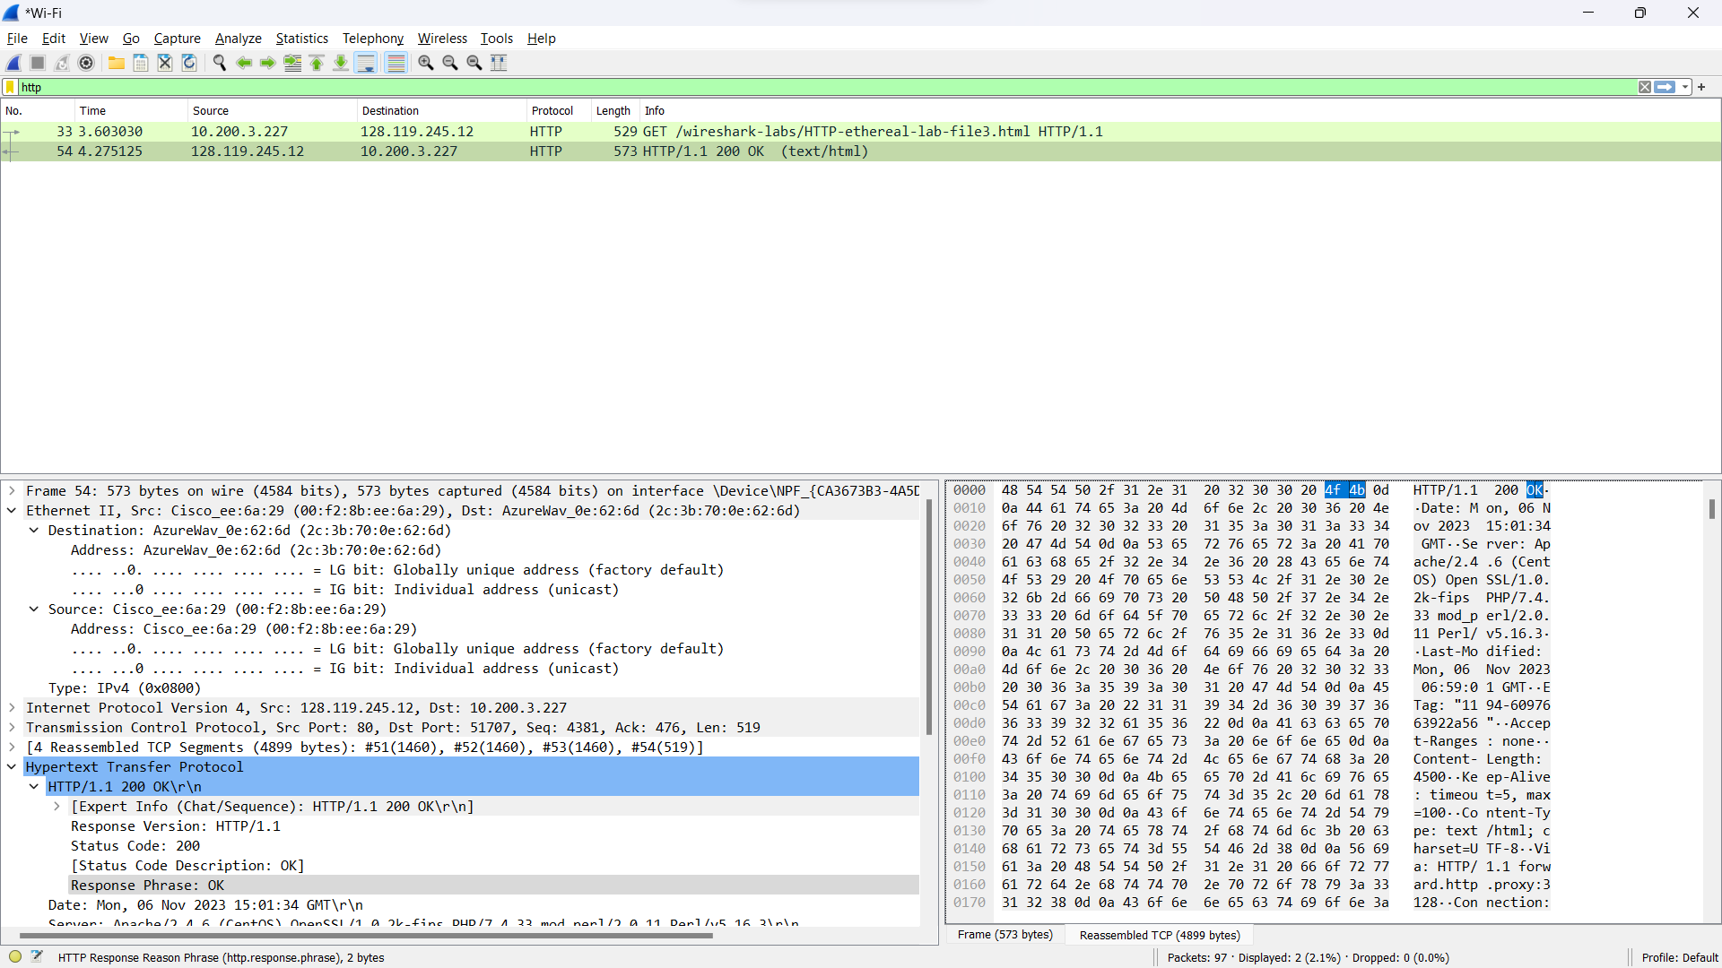

1. How many bytes from the very start of the Ethernet frame does the ASCII “O” in “OK” appear in the Ethernet frame?

* The ASCII ‘O’ in ‘OK’ appears 13 bytes from the start of the frame. It is shown that the ‘O’ starts from byte 4f and there are 13 bytes before it.

1. What is the hexadecimal value of the CRC field in this Ethernet frame?

* There is no CRC field in the ethernet frame.

Exercise 2.1.1

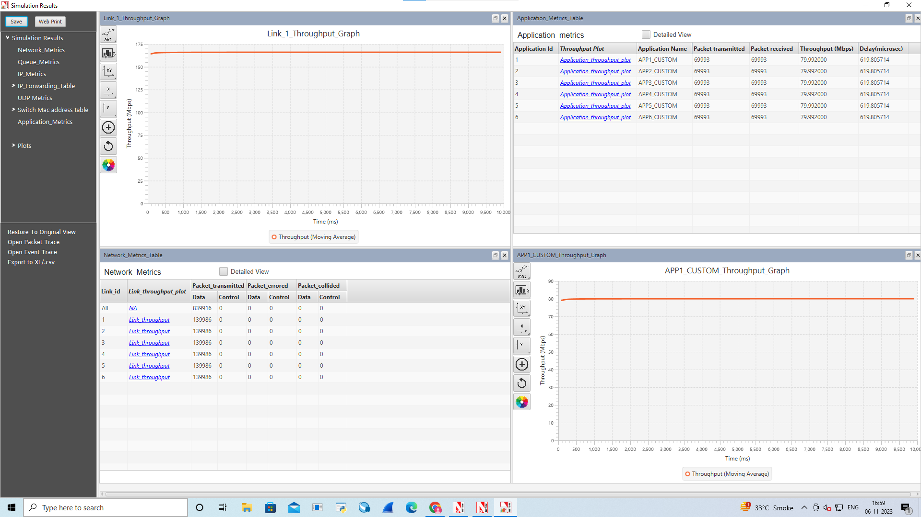

**Average Throughput (Mbps)**

|  |  |
| --- | --- |
| App 1 | 79.992000 |
| App 2 | 79.992000 |
| App 3 | 79.992000 |
| App 4 | 79.992000 |
| App 5 | 79.992000 |
| App 6 | 79.992000 |

Exercise 2.1.2

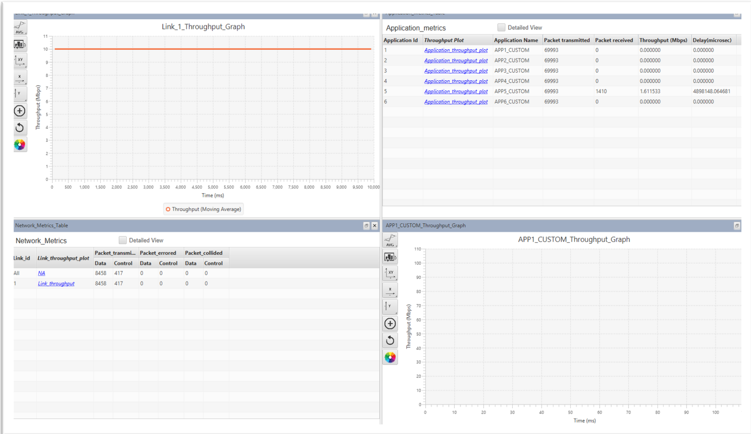

**Average Throughput (Mbps)**

|  |  |
| --- | --- |
| App 1 | 0 |
| App 2 | 0 |
| App 3 | 0 |
| App 4 | 0 |
| App 5 | 1.611533 |
| App 6 | 0 |

Exercise 2.1.3

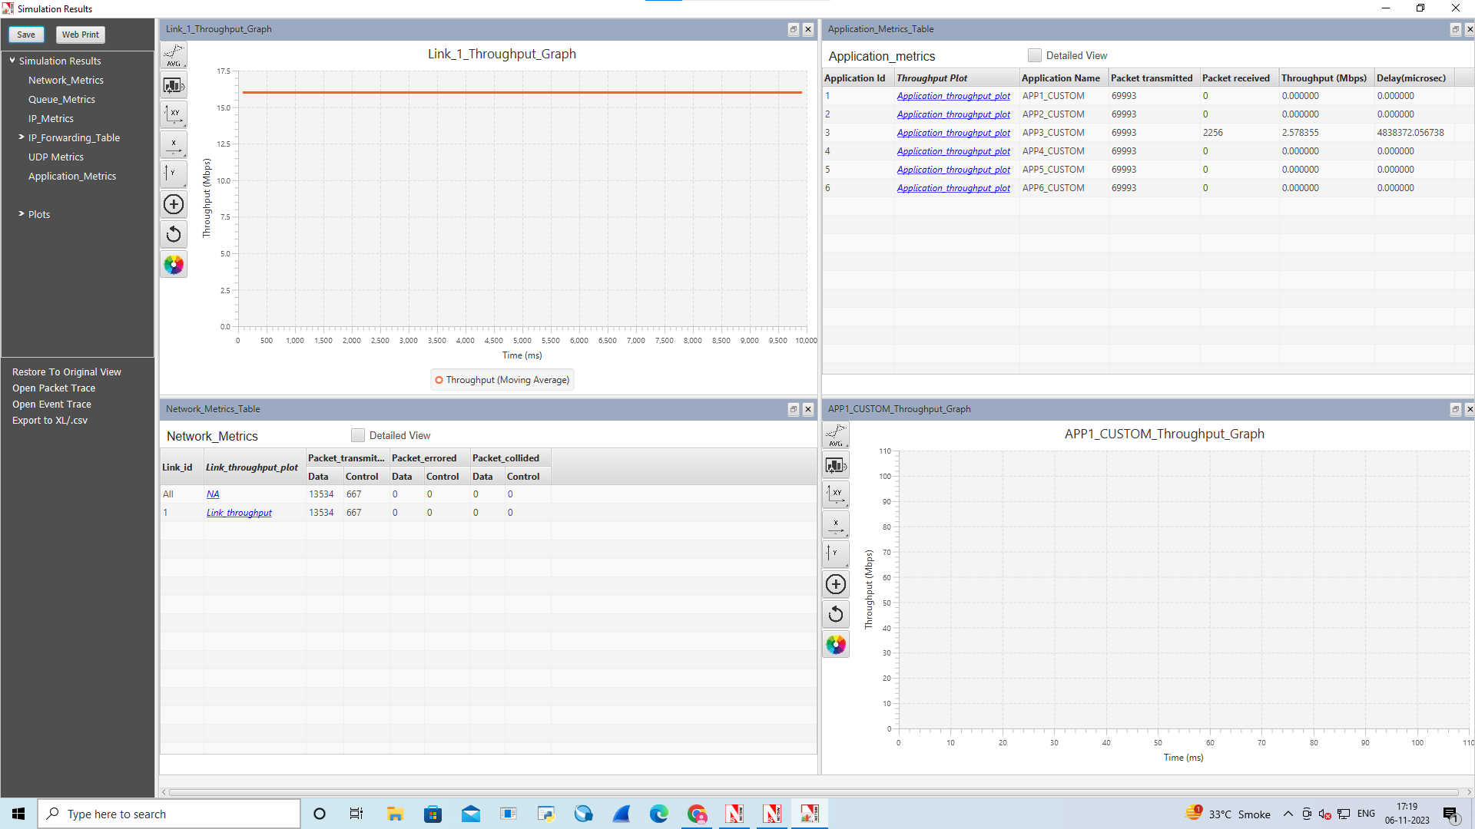

Average Throughput (Mbps)

|  |  |
| --- | --- |
| App 1 | 0 |
| App 2 | 0 |
| App 3 | 2.578355 |
| App 4 | 0 |
| App 5 | 0 |
| App 6 | 0 |